

Watershed – Village Umaria

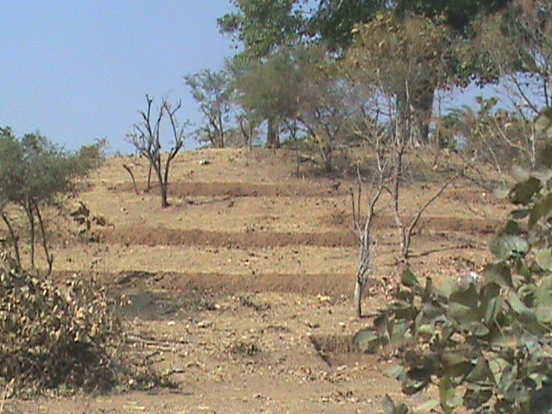
The farming environment in southern Rajasthan can be quite harsh. Our rains are concentrated in only two months of the year and due to the lands downward slope, this water mostly runs off taking precious soil and nutrients with it. Watershed treatment, a core tenet of Seva Mandir's natural resources management strategy, involves building several small structures to stop rain and soil run-off.

In 2005-06, the villagers of Umaria began such a program. The watershed is taken up in various phases i.e. taking the entire village piece by piece. First trenches are built and then plantation/seeds would be sown. A small dam (anicut) would be built. All works were constructed through community effort.

The villagers immediately get benefited from having access to wage labor opportunities, avoiding the difficulties and inhumanities often associated with migratory labor. Over time, the larger benefits of watershed treatment can be seen. Surrounding wells get recharged as the ground water table gets increased.

The water accumulated in the dam during the rains allows farmers to sow second and third crops. Without access to such irrigation, farmers can only farm in 4 months of the year. The balance of the year is spent doing migratory labor work while their lands lay fallow. Most importantly, soil erosion has been halted which ensures the long-term productivity and livelihood of these farmers.
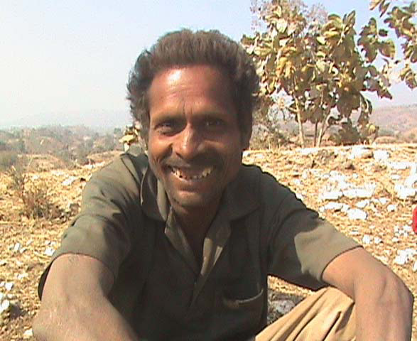
Shanker Sagia is one such farmer. He belongs to the poorest family of Umaria. He owns a small farm but it never produced enough to meet his family's yearly requirement of grains. He used to migrate in the balance of the year but now has been working in the village itself earning Rs. 60-80 every day.
There are as many as 120 such families in village Umaria who have been benefited from this program.

Please visit us at: www.sevamandir.org

